WEEK 7 – Recursion

Last Lecture

- ADT List

Outline of Today’s Lecture

- Recursion

Recursive Function Call

- A recursive call is a function call in which the called function is the same as the one making the call.

- In other words, recursion occurs when a function calls itself!

- We must avoid making an infinite sequence of function calls (infinite recursion).
Finding a Recursive Solution

- Each successive recursive call should bring you closer to a situation in which the answer is known.

- A case for which the answer is known (and can be expressed without recursion) is called a base case.

- Each recursive algorithm must have at least one base case, as well as the general (recursive) case
General format for
many recursive functions

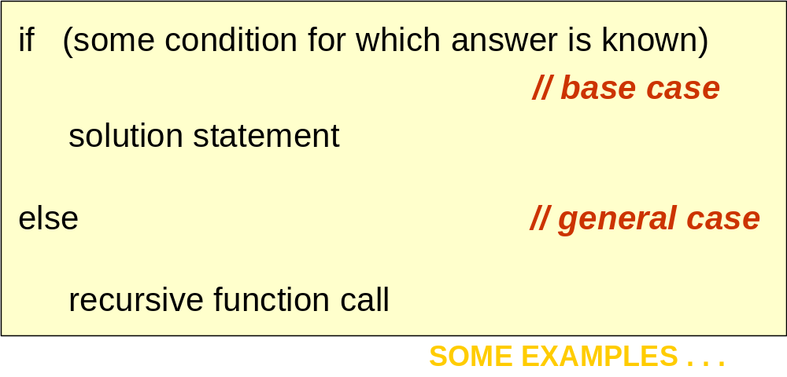
Writing a recursive function to find
n factorial

DISCUSSION

The function call Factorial(4) should have value 24, because that is 4 * 3 * 2 * 1 .

For a situation in which the answer is known, the value of 0! is 1.

So our base case could be along the lines of

if ( number == 0 )
return 1;

Writing a recursive function to find
Factorial(n)

Now for the general case . . .

The value of Factorial(n) can be written as
n * the product of the numbers from (n - 1) to 1,
that is,
n * (n - 1) * . . . * 1

or, n * Factorial(n - 1)

And notice that the recursive call Factorial(n - 1) gets us “closer” to the base case of Factorial(0).

Recursive Solution

int Factorial ( int number )
// Pre: number is assigned and number >= 0.
{
if ( number == 0) // base case
return 1 ;
else // general case
return number * Factorial ( number - 1 ) ;
}
?
Three-Question Method of verifying recursive functions

- Base-Case Question: Is there a nonrecursive way out of the function?

- Smaller-Caller Question: Does each recursive function call involve a smaller case of the original problem leading to the base case?

- General-Case Question: Assuming each recursive call works correctly, does the whole function work correctly?

Another example where recursion comes naturally

- From mathematics, we know that

2⁰ = 1 and 2⁵ = 2 * 2⁴

- In general,

x⁰ = 1 and x^{n} = x * x^{n-1}
for integer x, and integer n > 0.

- Here we are defining x^{n} recursively, in terms of x^{n-1}
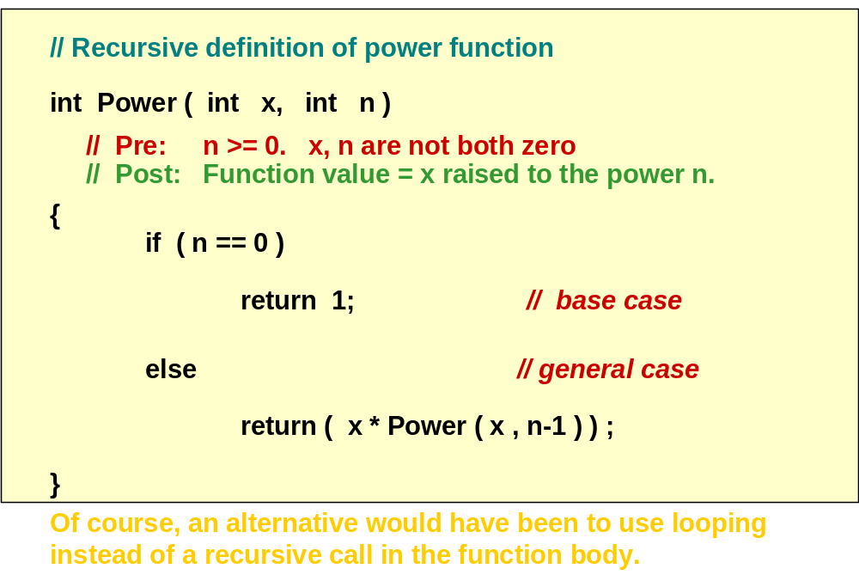
struct ListType (unsorted)

struct ListType

{
int length ; // number of elements in the list

int info[ MAX_ITEMS ] ;

} ;

ListType list ;
Recursive function to determine if value is in list
?
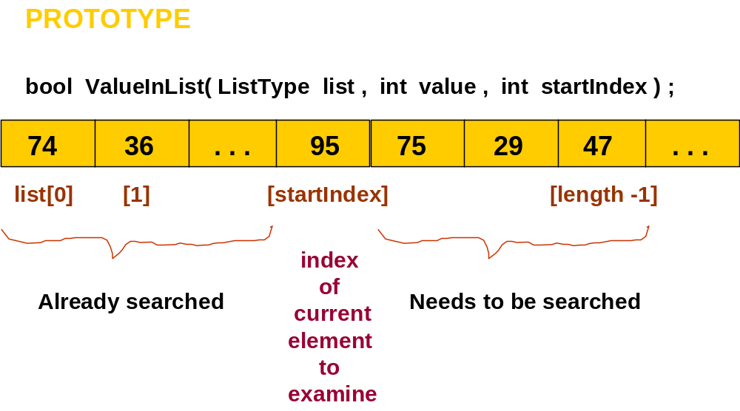

bool ValueInList ( ListType list , int value , int startIndex )

// Searches list for value between positions startIndex
// and list.length-1
// Pre: list.info[ startIndex ] . . list.info[ list.length - 1 ]
// contain values to be searched
// Post: Function value =
// ( value exists in list.info[ startIndex ] . . list.info[ list.length - 1 ] )
{
if ( list.info[startIndex] == value ) // one base case return true ;
else if (startIndex == list.length -1 ) // another base case
return false ;
else // general case
return ValueInList( list, value, startIndex + 1 ) ;
}
“Why use recursion?”

Those examples could have been written without recursion, using iteration instead. The iterative solution uses a loop, and the recursive solution uses an if statement.

However, for certain problems the recursive solution is the most natural solution.

Fig. 1
Function BinarySearch( )

- BinarySearch takes sorted array info, and two subscripts, fromLoc and toLoc, and item as arguments. It returns false if item is not found in the elements info[fromLoc…toLoc]. Otherwise, it returns true.

- BinarySearch can be written using iteration, or using recursion.

Fig. 2
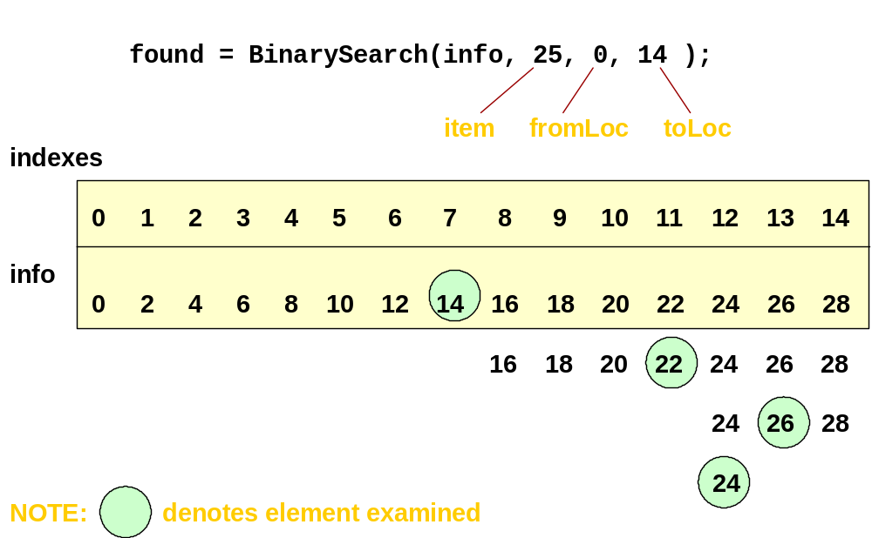
// Recursive definition

template<class ItemType>
bool BinarySearch ( ItemType info[ ] , ItemType item ,
int fromLoc , int toLoc )
// Pre: info [ fromLoc . . toLoc ] sorted in ascending order
// Post: Function value = ( item in info [ fromLoc . . toLoc] )

{ int mid ;
if ( fromLoc > toLoc ) // base case -- not found
return false ;
else {
mid = ( fromLoc + toLoc ) / 2 ;

if ( info [ mid ] == item ) // base case-- found at mid

return true ;

else if ( item < info [ mid ] ) // search lower half
return BinarySearch ( info, item, fromLoc, mid-1 ) ;
else // search upper half
return BinarySearch( info, item, mid + 1, toLoc ) ;
}

}
fig 3
When a function is called...

- A transfer of control occurs from the calling block to the code of the function. It is necessary that there be a return to the correct place in the calling block after the function code is executed. This correct place is called the return address.

- When any function is called, the run-time stack is used. On this stack is placed an activation record (stack frame) for the function call.

Fig. 4
Stack Activation Frames

- The activation record stores the return address for this function call, and also the parameters, local variables, and the function’s return value, if non-void.

- The activation record for a particular function call is popped off the run-time stack when the final closing brace in the function code is reached, or when a return statement is reached in the function code.

- At this time the function’s return value, if non-void, is brought back to the calling block return address for use there.
// Another recursive function

int Func ( int a, int b )

// Pre: a and b have been assigned values
// Post: Function value = ??

{
int result;

if ( b == 0 ) // base case

result = 0;

else if ( b > 0 ) // first general case

result = a + Func ( a , b - 1 ) ) ; // instruction 50

else // second general case
result = Func ( - a , - b ) ; // instruction 70

return result;

} fig. 5
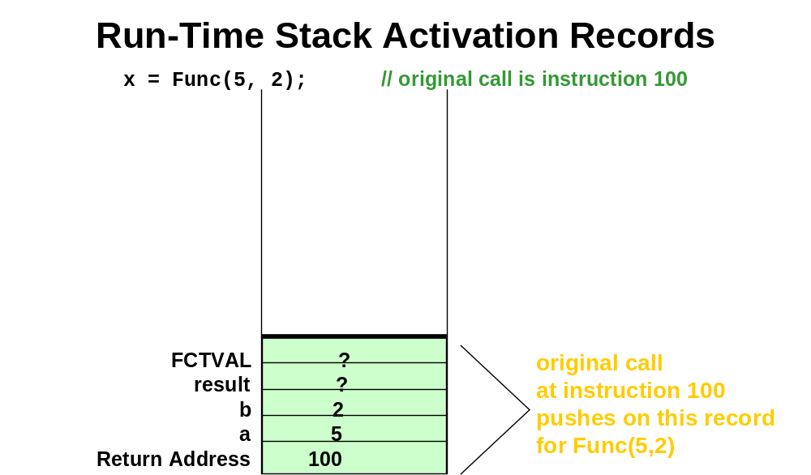
fig. 6

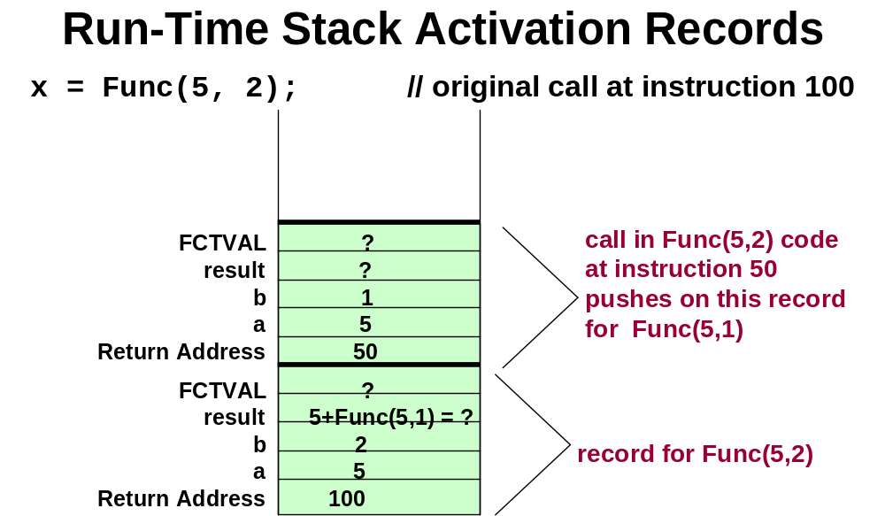
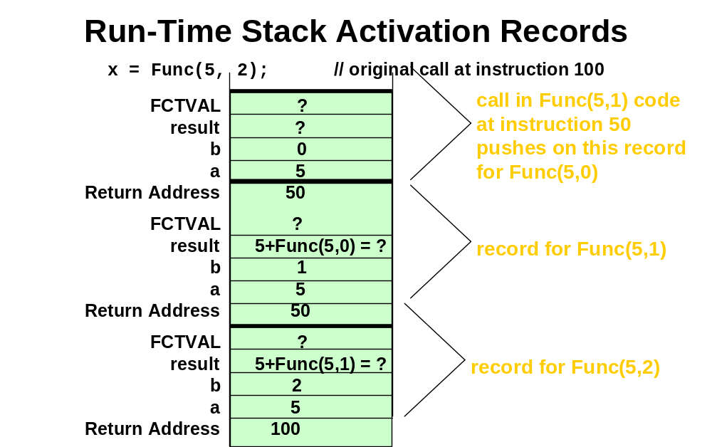
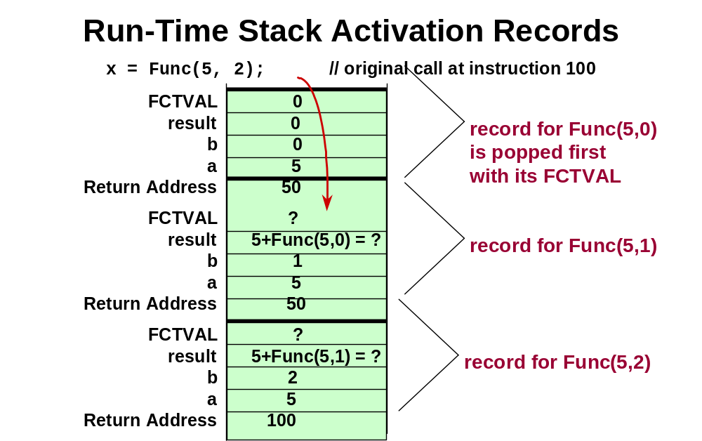
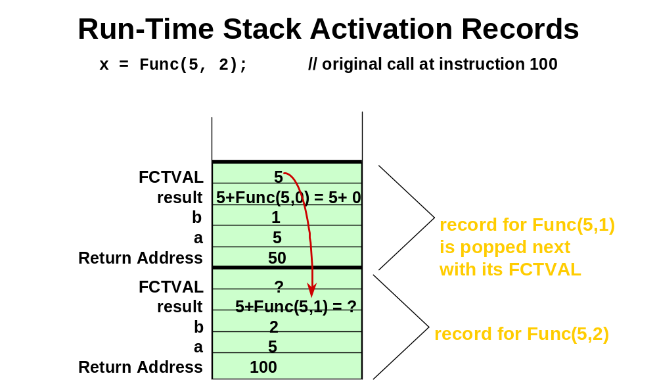
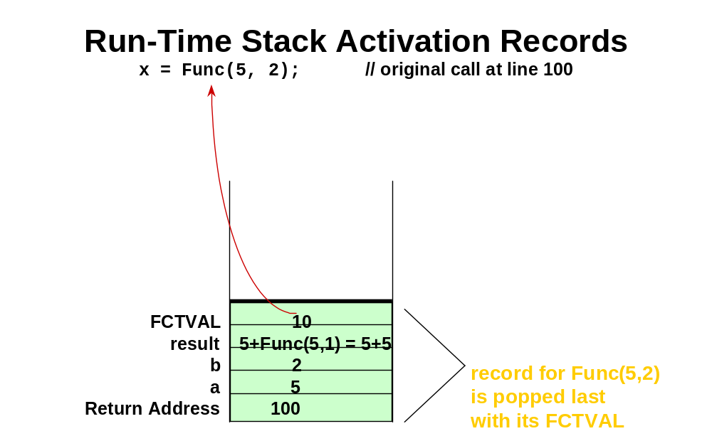
?

Tail Recursion

- The case in which a function contains only a single recursive call and it is the last statement to be executed in the function.

Tail recursion can be replaced by iteration to remove recursion from the solution as in the next example.

// USES TAIL RECURSION

bool ValueInList ( ListType list , int value , int startIndex )

// Searches list for value between positions startIndex
// and list.length-1
// Pre: list.info[ startIndex ] . . list.info[ list.length - 1 ]
// contain values to be searched
// Post: Function value =
// ( value exists in list.info[ startIndex ] . . list.info[ list.length - 1 ] )
{
if ( list.info[startIndex] == value ) // one base case return true ;
else if (startIndex == list.length -1 ) // another base case
return false ;
else // general case
return ValueInList( list, value, startIndex + 1 ) ;
}

// ITERATIVE SOLUTION

bool ValueInList ( ListType list , int value , int startIndex )

// Searches list for value between positions startIndex
// and list.length-1
// Pre: list.info[ startIndex ] . . list.info[ list.length - 1 ]
// contain values to be searched
// Post: Function value =
// ( value exists in list.info[ startIndex ] . . list.info[ list.length - 1 ] )
{ bool found = false ;
while ( !found && startIndex < list.length )
{ if ( value == list.info[ startIndex ] )
found = true ;
else startIndex++ ;
}
return found ;
}
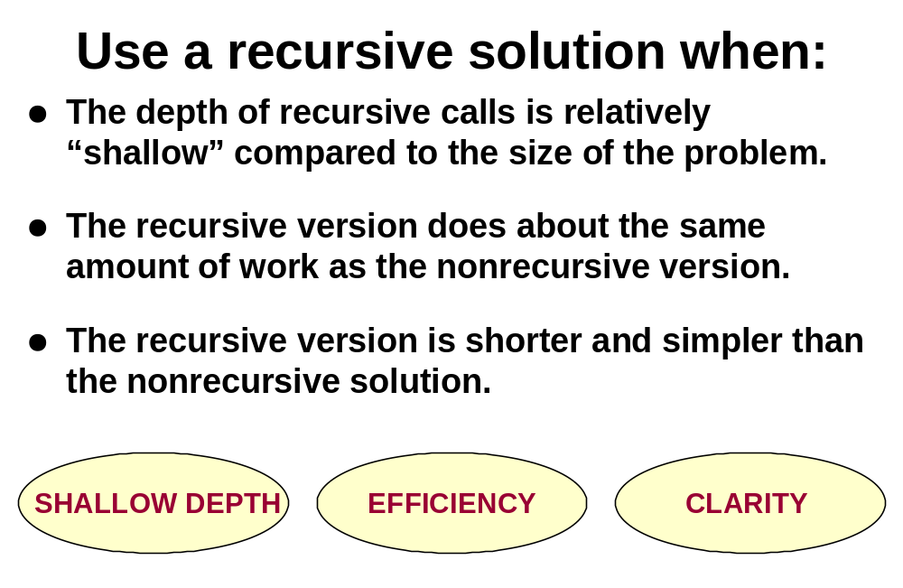

Today’s Lecture

- Recursion

Next Lecture

- Midterm Review

